Before attempting the task please go the below Wiki link to understand the concept of ‘**Import Set Web Service**’.

<http://wiki.servicenow.com/index.php?title=Web_Service_Import_Sets#gsc.tab=0>

**Task1:** Create an import set web service in service now demo instance which creates incident tickets in another SN demo instance.

Steps:

1. Log into any of the demo SN instance as Service Now Administrator.
2. In the navigation go to 🡪 **System Web Services > Create New.**
3. Create a Web service named **– “Create Incident”.**

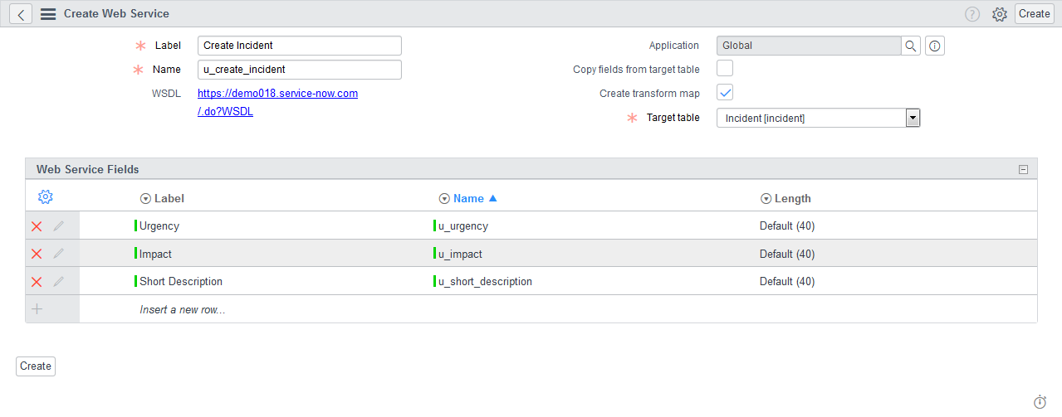

1. Include the fields shown in the image to the web service and click on ‘Create’. The form will be redirected to the ‘Transform Map’ page.

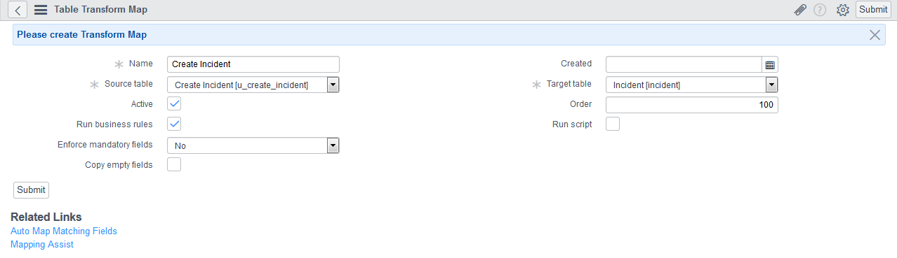

1. Click on “Auto Map Matching Field” link.

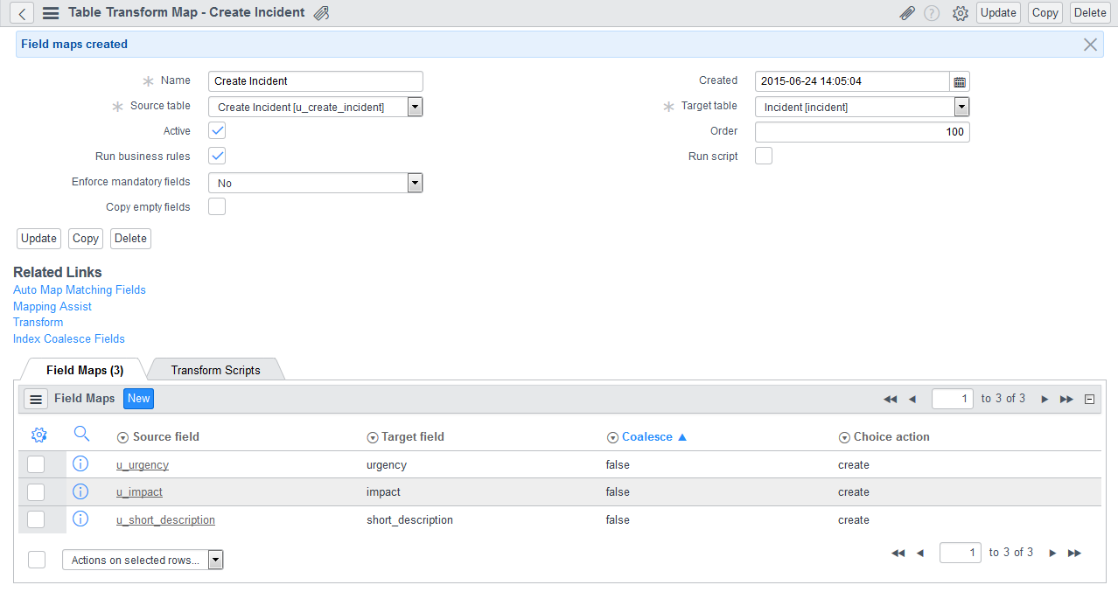

1. Now, to test the above web service login into a different SN Demo instance.
2. Go to 🡪 **System Web Services > SOAP Message**. Create a new SOAP message – ‘Test Incident’.

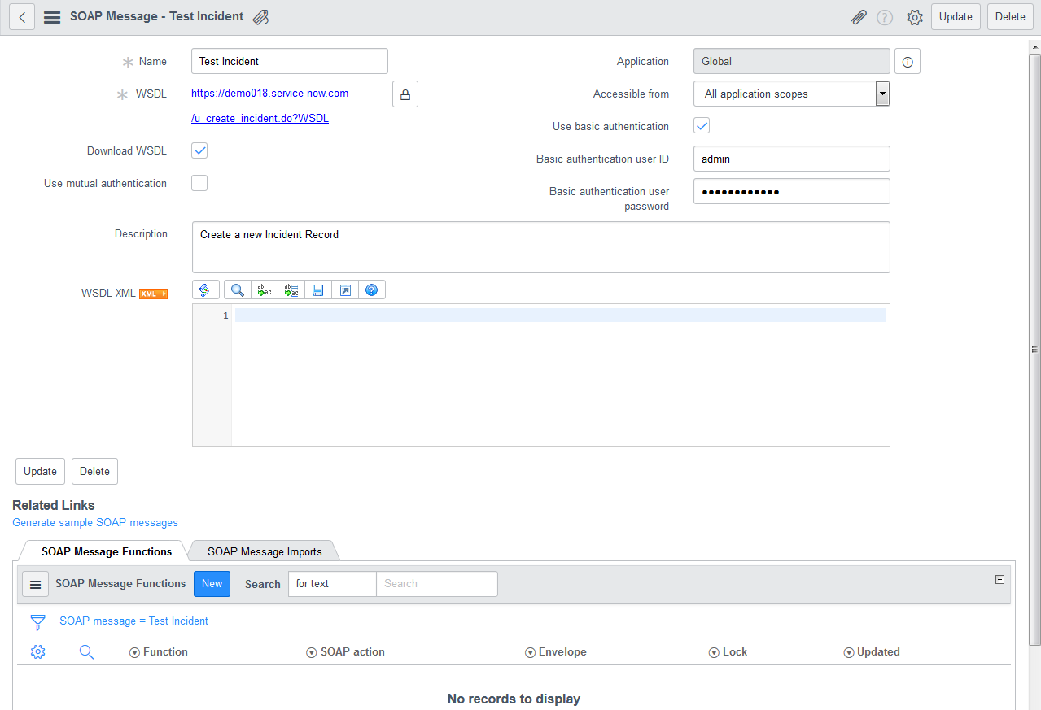

1. Click on the link “Generate sample SOAP messages”. Then open the ‘insert’ method under the SOAP message Function related List.

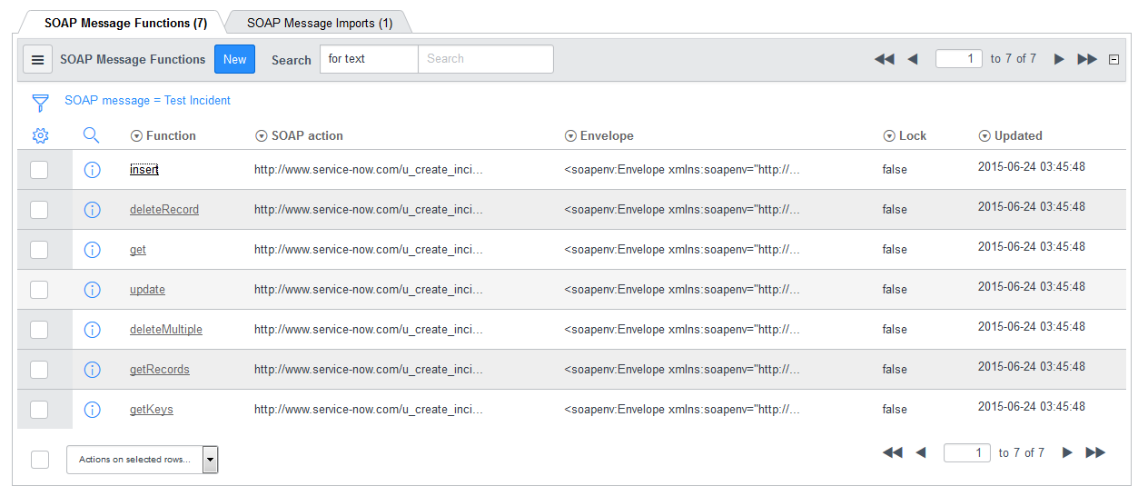

1. On the ‘Insert’ method form select ‘**Basic authentication**’. Update username & password.

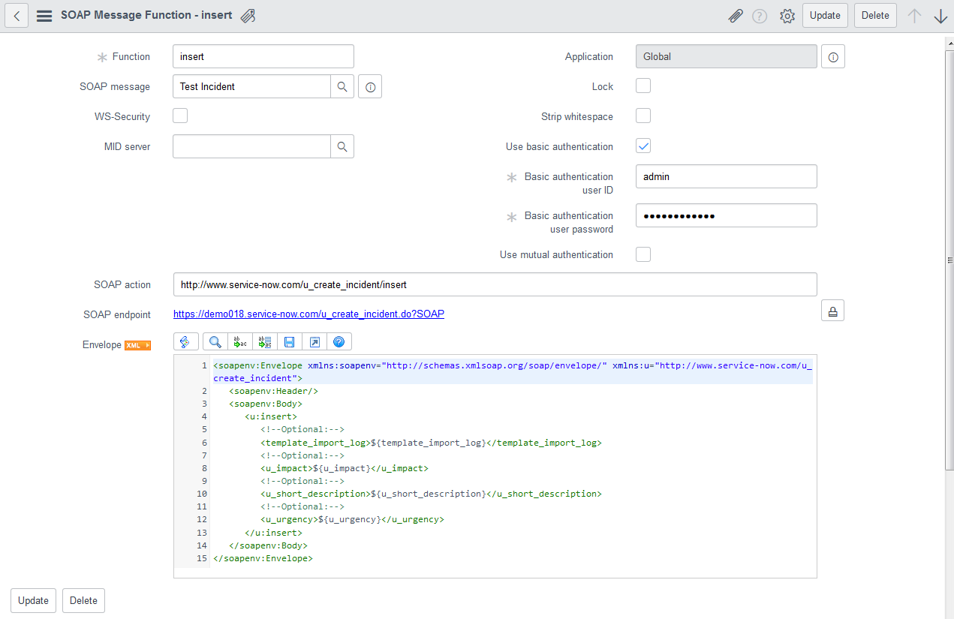

1. Now to test the web service, hardcode the payload parameters as below:

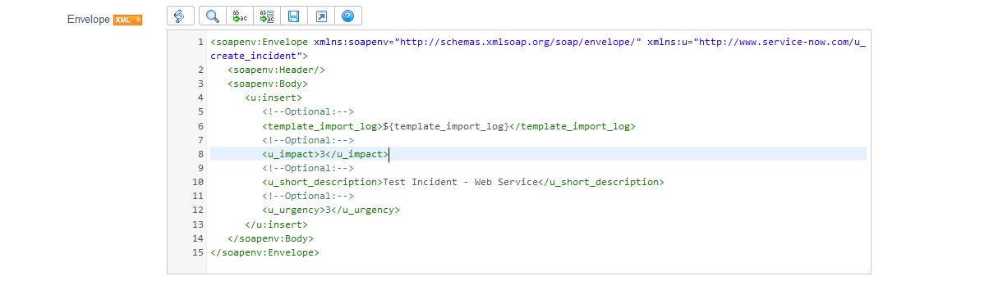

1. Click on the ‘test’ link. The Http Status should return **200** with below response.

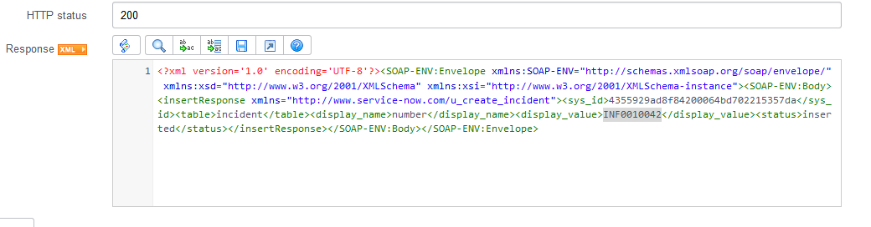

1. Now go to the target instance, to look for the created incident ticket.

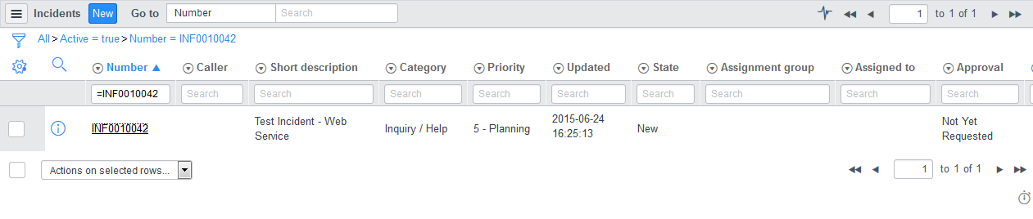

**Task 2**: In the same web service do a validation to check empty fields. Do a check to mark ‘Short Description’ as a mandatory field and should not be blank.

Steps:

1. Go to 🡪 **System Web Services 🡪 Create Incident** in the Target Instance.
2. Open the Transform Map. Check the ‘Run Script’ field. Modify the script as below:

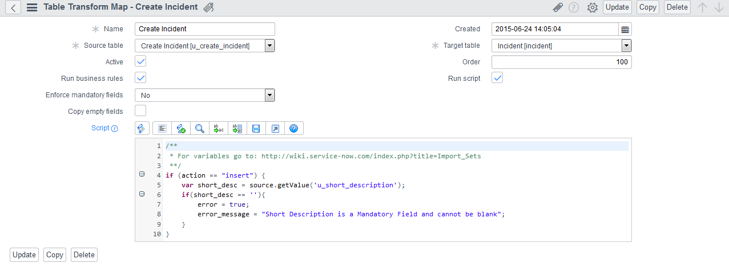

1. Now to test the changes, go to the previous SN Demo instance where the SOAP message “Test Incident” is available.
2. Modify the payload and leave ‘short description’ as blank.
3. The response should show the error message given in the script.